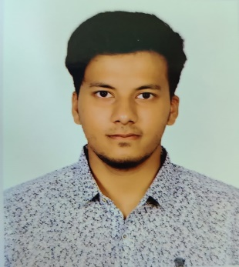**Din Islam Zubair**

Mitali housing, North Kafrul, Dhaka cantonment, Dhaka- 1206

Contact: 01988597545

**Email:** [sifatislam625@gmail.com](mailto:sifatislam625@gmail.com)

## Career Objective



Web Developer specializing in back-end and front-end development also specializing in Networking site. Well versed in numerous programming languages including C, C+ , C#, PHP, JavaScript, MySQL. Seeking an organization where I can use my talents and skills to grow in the field of Computer Science. Secure position in a creative and dynamic work environment where I can apply my skills.

## Projects

* Hotel Management System in SQL Database.
* Home Management System in Java.
* Advance Library management system in C#.
* Online Polling System in Web Technologies(PHP, Ajax ,jQuery, Angular JS,CDN JS,CSS3,HTML5)

## Skills

* Fast learner
* Strong Decision maker
* Good Analytical skill
* Hard working
* Innovative
* Service-Focused

## Experience:

## Worked on Rehash Accessories LTD in IT and Web development as Internship .

## Expertise

* **Languages :** C, C++, java, C#, Php, JavaScript, HTML5, CSS
* **CSS Framework :** Bootstrap
* **Frontend :**CSS3,HTML5,Ajax, React JS, Angular JS, jQuery, UI/UX design.
* **Operating System:** Microsoft Windows, LINUX, Mac(OS)
* **Database :**MySQL, PL/SQL, XAMPP ,WAMPP ,Mongo DB
* **Others :** Cisco packet tracer, AutoCAD, MS Word, MS Excel, MS PowerPoint
* **Softwares :** Code Blocks, Visual Studio ,NetBeans, XCode(Mac) ,AutoCAD, GitHub, Trello
* **IT/Networking :** Dynamic Routing, Static Routing, Mikrotic Router Configuration, MATLAB

## Academic Qualifications

|  |  |  |  |  |
| --- | --- | --- | --- | --- |
| **Degree Name** | **Concentration** | **Institution** | **Result** | **Passing Year** |
| BSC | Computer Science & Software Engineering | American International University-Bangladesh | CGPA-3.16 out of 4.00 | 2020  October |
| HSC | Science | B,N College Dhaka | GPA- 4.17 out of 5.00 | 2016 |
| SSC | Science | B,N College Dhaka | GPA- 5.00 out of 5.00 | 2014 |

## Linguistic eloquence:

**Bengali:** Reading, Writing, Speaking and Listening: Excellent

**English:** Reading, Writing, Speaking and Listening: Excellent

## Achievements

* Programming Foundations with JS, Html, CSS (Coursera Certification)
* Programming with Python (Coursera Certification)

## Reference

**MD MASUM BILLAH**

Lecturer in FSIT

American International University-Bangladesh (AIUB)

Address : 408/1, Kuratoli, Khilkhet, Dhaka 1229, Bangladesh

Contact : 01646677086

Email : [billah.masumcu@aiub.edu](mailto:billah.masumcu@aiub.edu)

**Shahadat Alam**

In Sales department

Computer Services and LTD

Address : East Kafrul Dhaka cantonment

Email : [Shahadat.alam@computerservicesltd.com](mailto:Shahadat.alam@computerservicesltd.com)

**SUJAN HOWLADER**

Lecturer in (EEE)

American International University-Bangladesh (AIUB)

Address : Khilgaon, Dhaka

Email : [sujan@aiub.edu](mailto:sujan@aiub.edu)